CASH JOURNAL

The Following are the steps in Cash Journal Creation

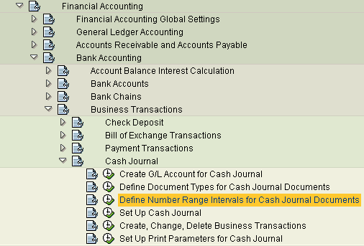

Create G/L Account for Cash Journal

For Each Cash journal one GL account has to be created. The above transaction simply take to Transaction code : FS00. Create new GL account is required.

Define Document Types for Cash Journal Documents

We have to specify the document types to be used for different transactions in Cash journals. This transaction simply take you to Transaction code : OBA7. It is sugestable to create different document types for Cash journal GL postings, cash journal vendor payment and receipt and Customer receipt and payment.. If you create new document types pl create new number ranges for same and assign to them.

Define number range intervel for cash journal Documents.

You have to define a number range interval for cash journal documents. Each document then receives a unique number that does not clash with the G/L document number.
( Document number ranges and cash journal document number ranges are different. This will be prepared at company code level . same number range will be used by all cash journals in that company code )
Requirements
Determine whether the number range interval 01 has already been predefined by the system.
Activities
If number range interval 01 has not been predefined, define the interval in the company code required, usually with a document number
interval from 1000000000 to 1499999999.
Note This number range assigns a unique number per company code to each cash journal document. In addition, the cash journal documents are numbered sequentially per company code and cash journal.
Example

Set up cash Journal

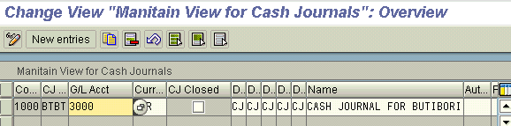

Here we have fill the following fields

Company code : required company code for which the Cash journal we are going to use.
CJ : Give some abravation to cash journal (you can create more than one cash journal in a company code)
GL Account: Gl account number in which transactions are made for this gl account.

Currency: Currency in which cash Journal is going to be prepared.
CJ closed: If you select this indicator you cant use this journal for further postings.
Document types for different transactions : assign related document type to prepare automatic postings.

Name : name of cash journal (details name for the above abravation)

Create Change and Delete Business Transactions

In This Transaction you will create Different business Transactions like paying rent, receipt from sbi, deposit to bank etc. and assign GL account related to that transaction.

This will be use full for further processing. While using the Cash journal you will select the name of the transction and do entries. System automatically determines the related GL account number and poste the documents. (transaction has to be maintained for each transaction to be used in Cash journal)

Sample transactions maintained for cash receipt and payment from and to bank.

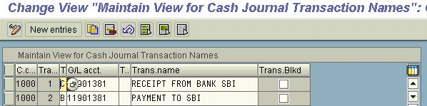

Set Up Print Parameters for Cash Journal
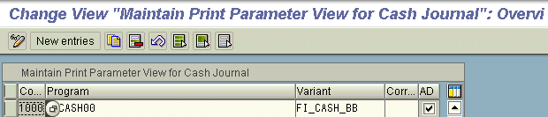
In order to print the cash journal and the cash journal receipts, you have to set up the corresponding print program parameters per company code.
Activities
1. Enter the appropriate company code.
2. Specify the following print program parameters per company code:
- For the cash journal:
  - Print program
usually RFCASH00
  - Report variant
For example, with entries FI_CASH_BB (Opening balance text), FI_CASH_EB (Closing balance text), FI_CASH_CF (C/F text), FI_CASH_SI (Signature text)
- For the cash journal receipts:
  - Correspondence type
For example
  - SAPC1 Accounting document
If you set the indicator Accounting documents, the receipts are printed based on the FI documents. If you do not set the indicator, you can print all the documents saved in the cash journal based on the cash journal documents. Not setting the indicator is therefore recommended.

with this Configuration is completed.

Transactions for cash Journal FBCJ

View is as follows
Ask for company code and name of Cash journal

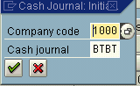

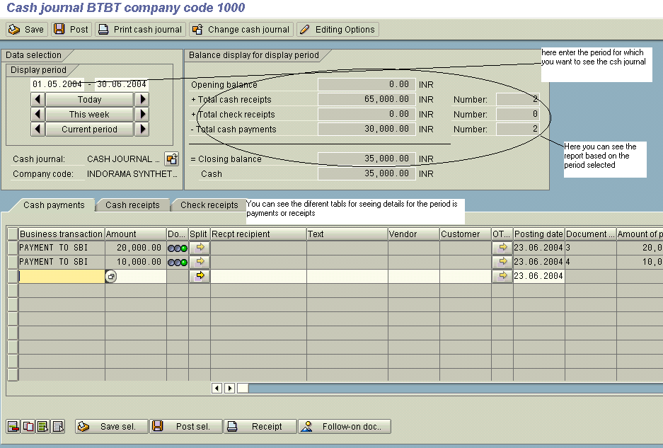
Select a Business transaction in related tab (cash receipt or payment) enter the amount and save. By this above status will be changed. And document will be posted in data base.

You can select another Cash Journal by clicking this button .

